**========Project 5=======**

**Scheduling a basic job in jenkins**

Task1: Create a free style project

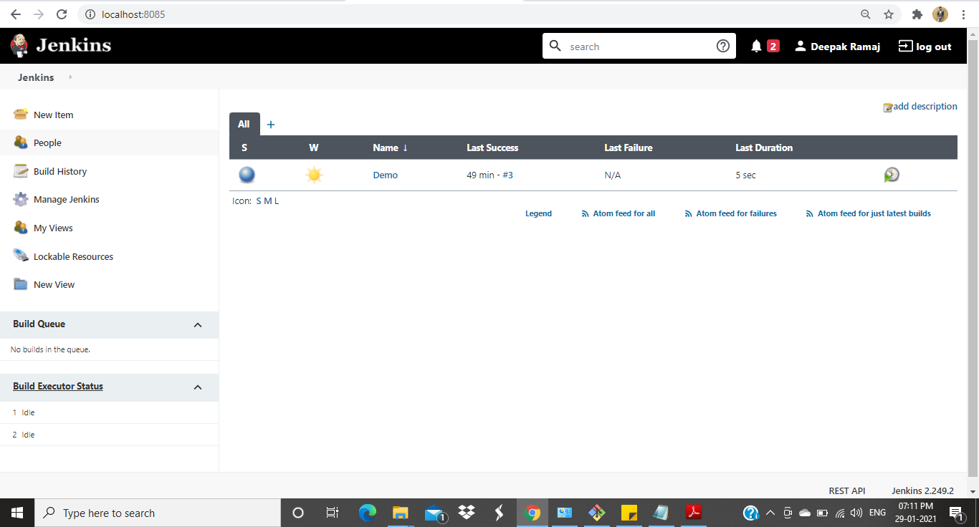

**Fig 1. Jenkins home page**

Task2: Configure git SCM

Refspec: +refs/pull/*:refs/remotes/origin/pr/*

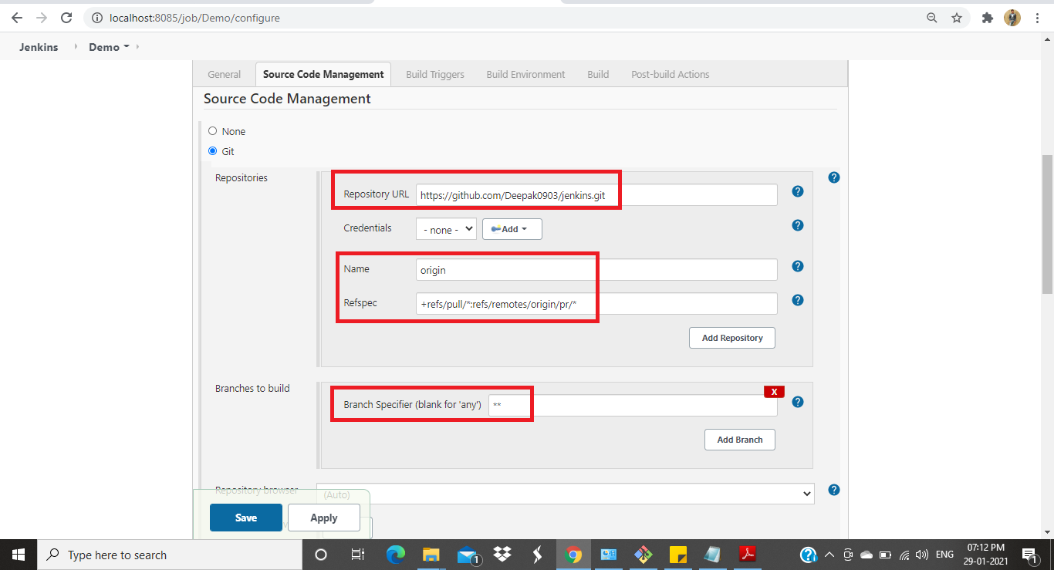

**Fig 2. Git Source code management tab**

Task3: Add build step-java commands in execute windows batch commands

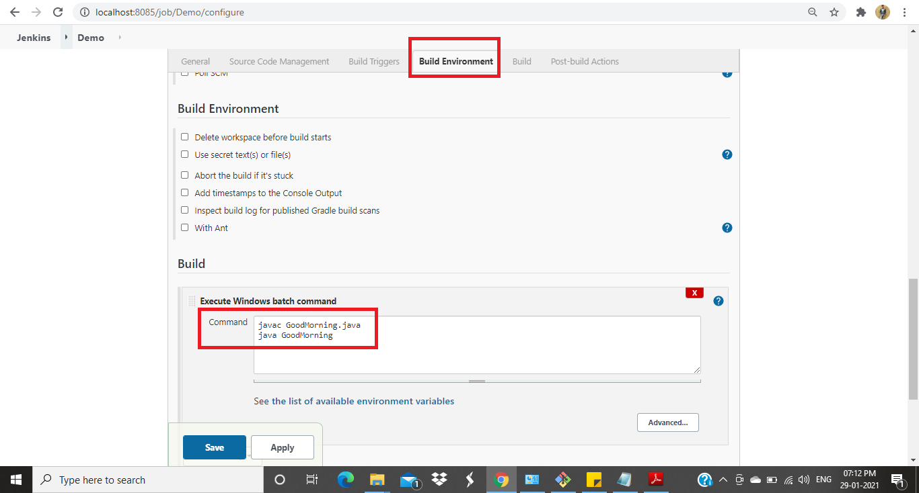

**Fig 3. Build Environment**

Task4: Run a build and show console output

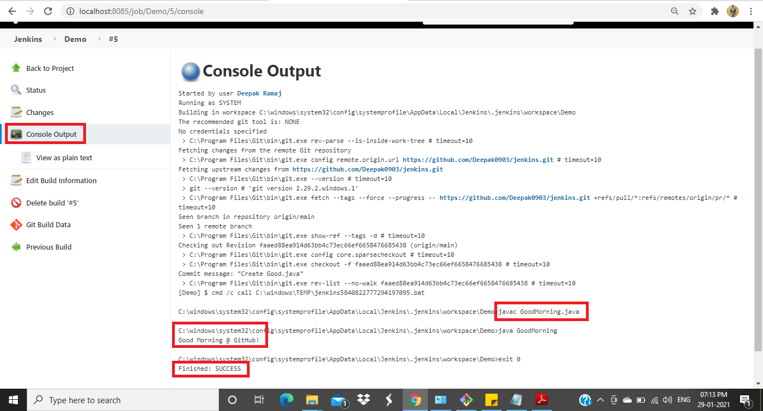

**Fig 4. Console output**